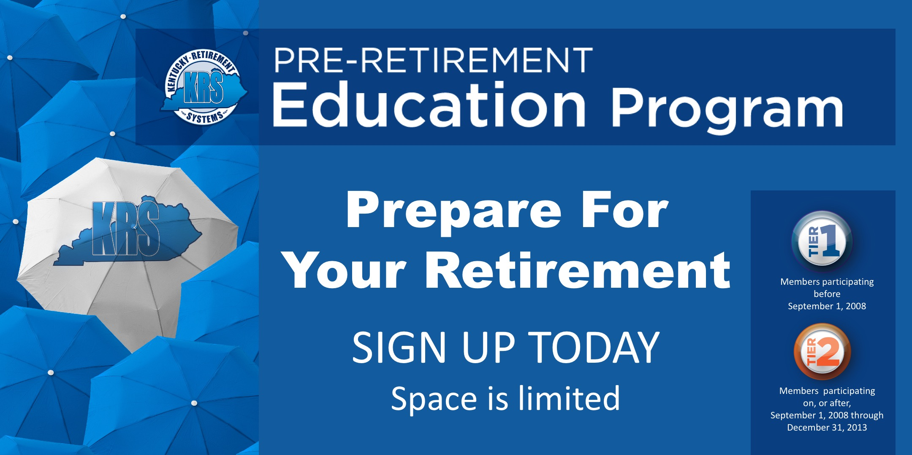

You can find more information here. These sessions are specifically for employees in the Tier 1 and 2 within 5 years of retirement. You can contact KRS for more information by calling 800-928-4646.

